**Course 1 Notes**

Returns: In **finance**, **return** is a profit on an investment. It comprises any change in value of the investment, and/or cash flows which the investor receives from the investment, such as interest payments or dividends. It may be measured either in absolute terms (e.g., dollars) or as a percentage of the amount invested.

Useful pandas/numpy operations: pct_change, prod

Price return (haven’t subtracted by 1)?

Def De-mean: Just removing the mean from your dataset

* Volatility often measured with variance and standard deviation

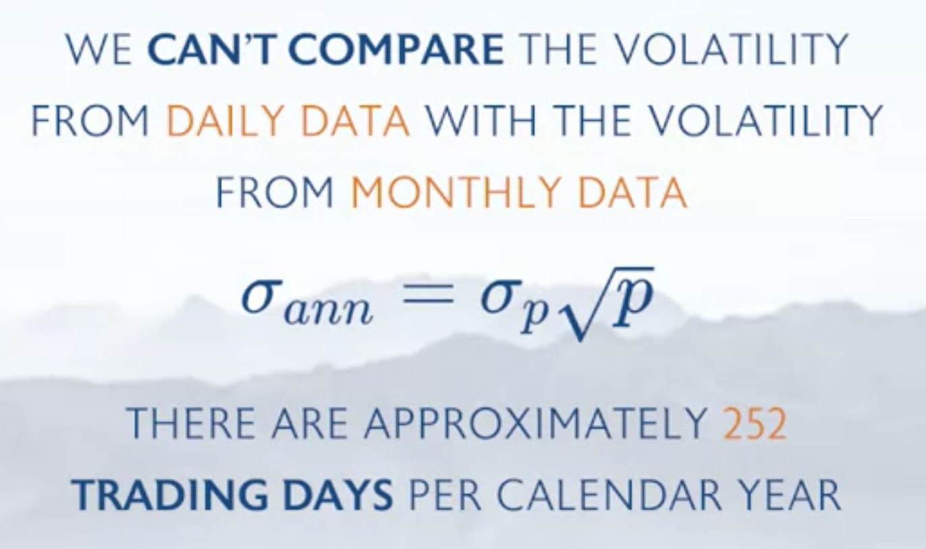

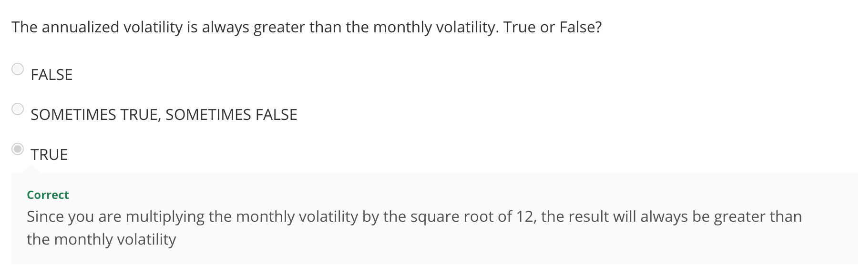

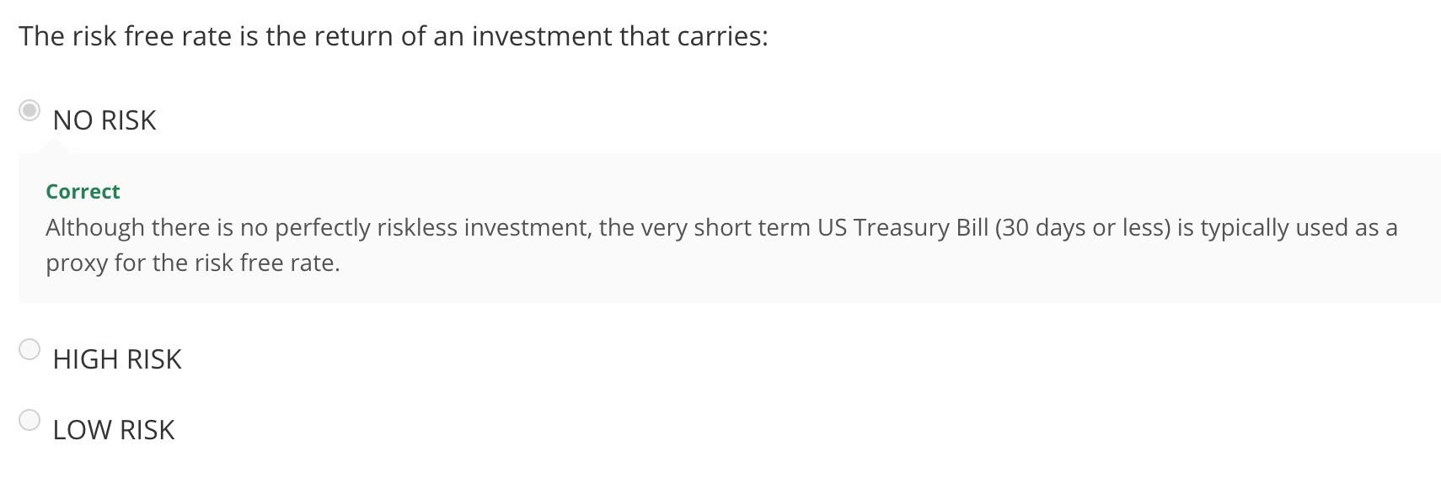

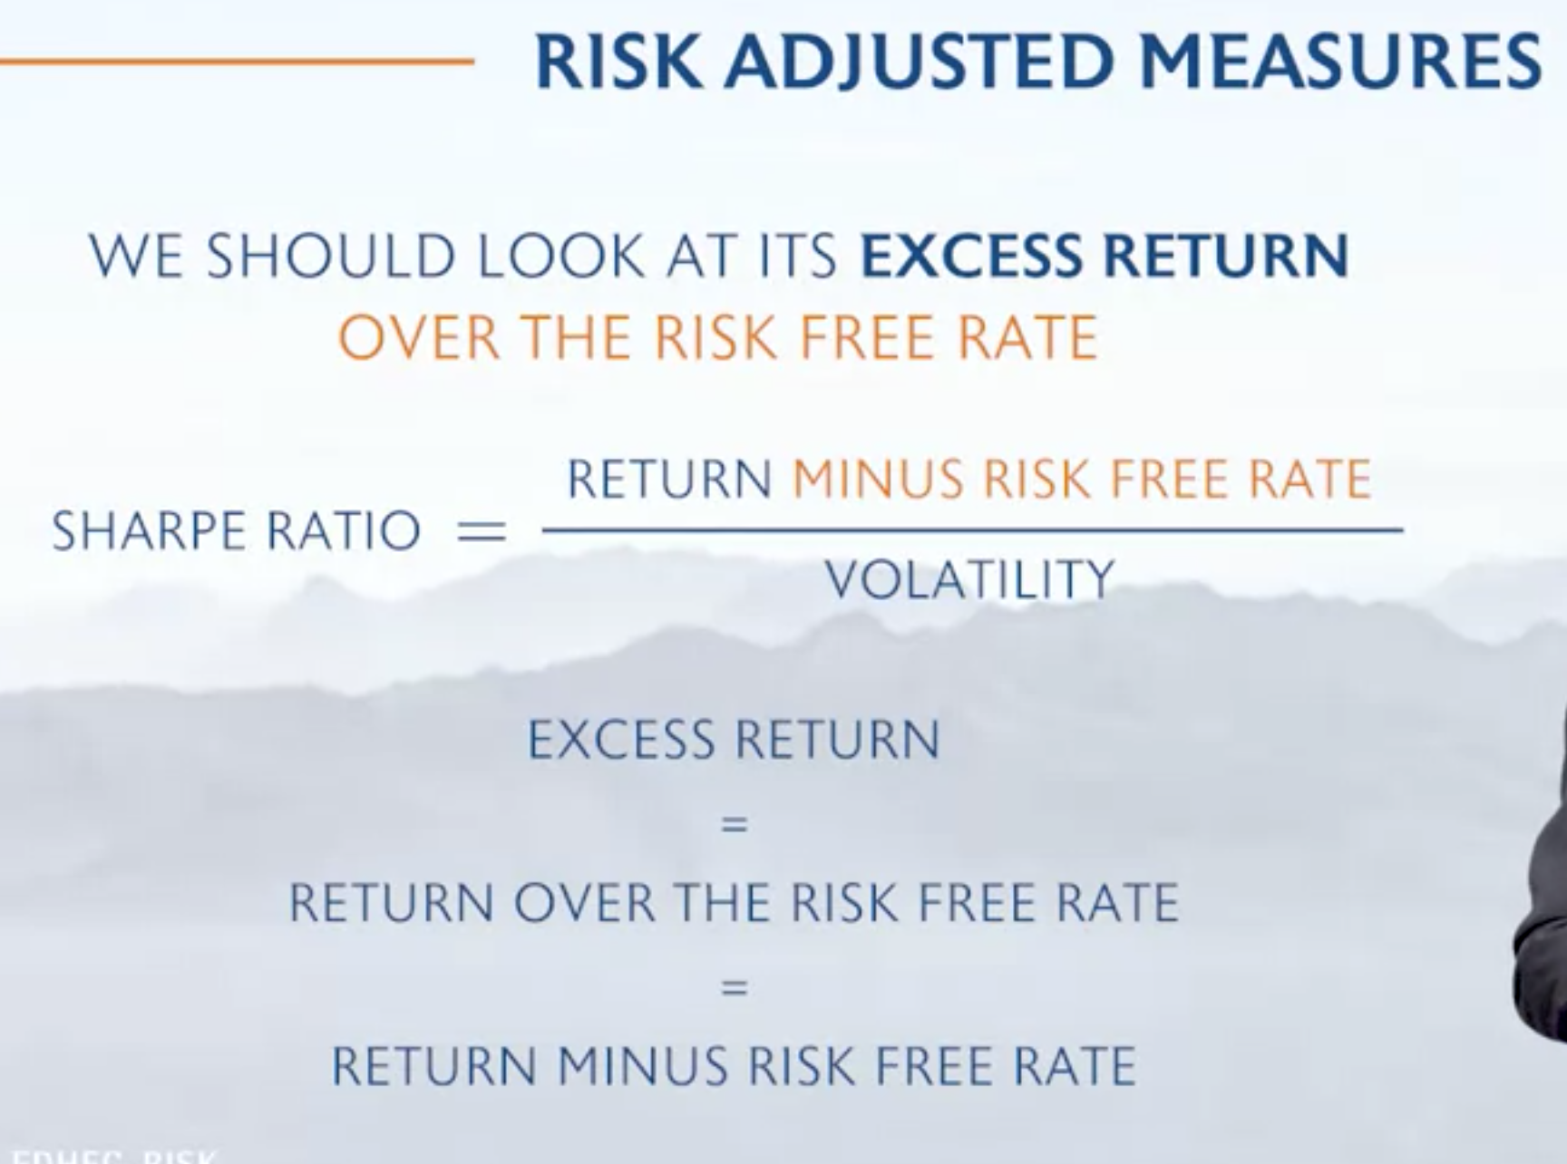

SHARPE RATIO:

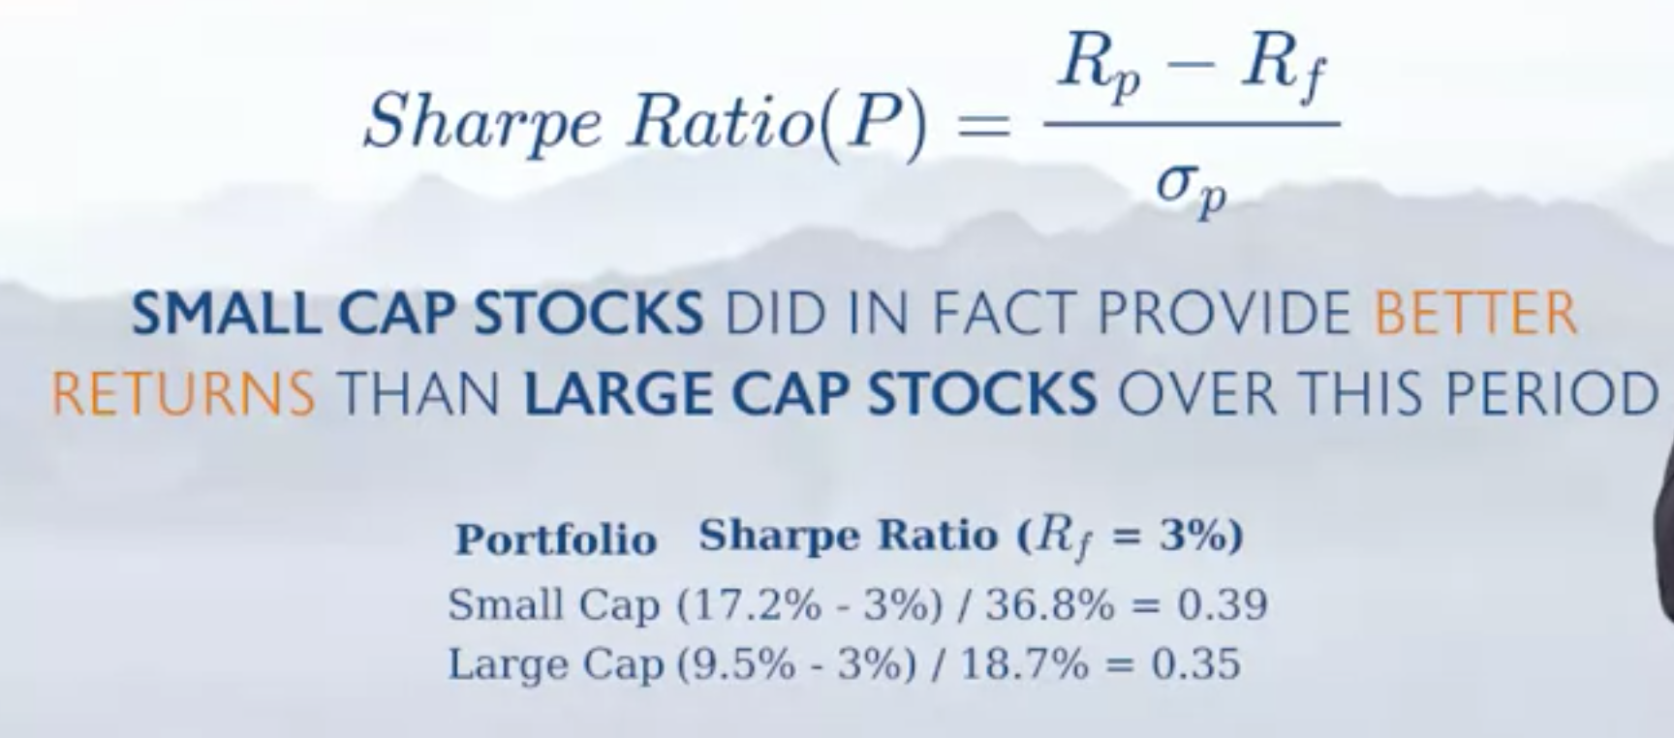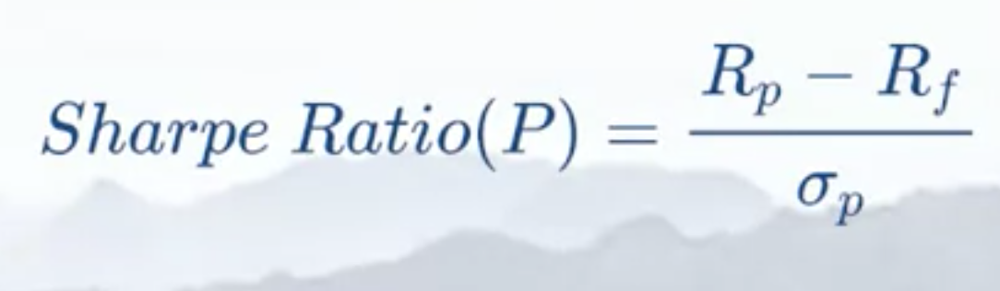

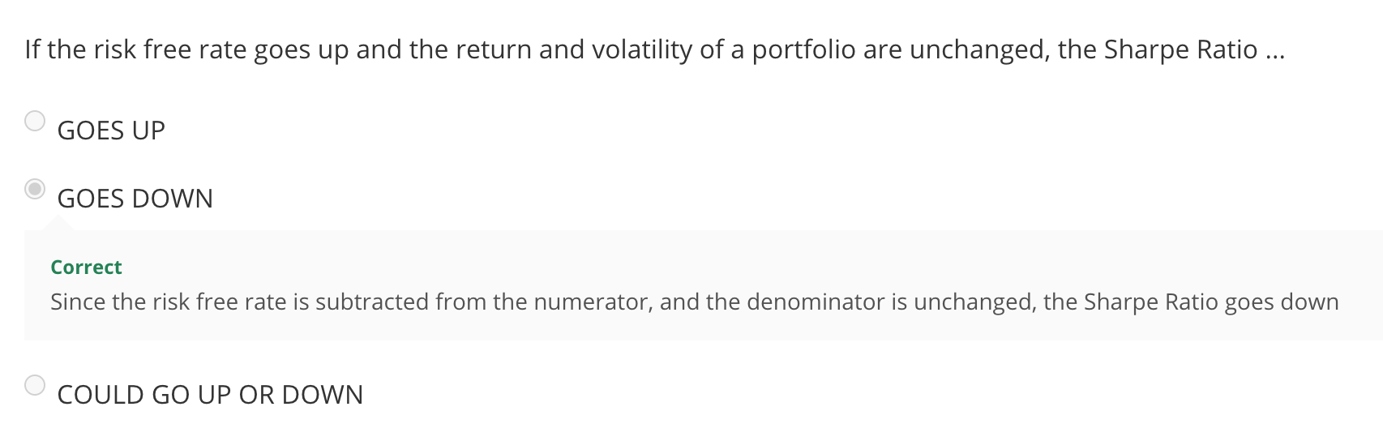

Using .std will yield different results from manual calculation because .std method will use N-1

* Sample (n-1) vs Population

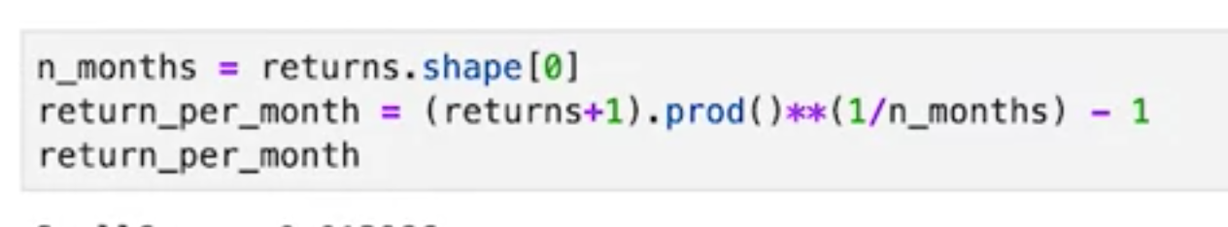

Remember that you can use the INVERSE formula to jump between time classes

**Measuring Max Drawdown**

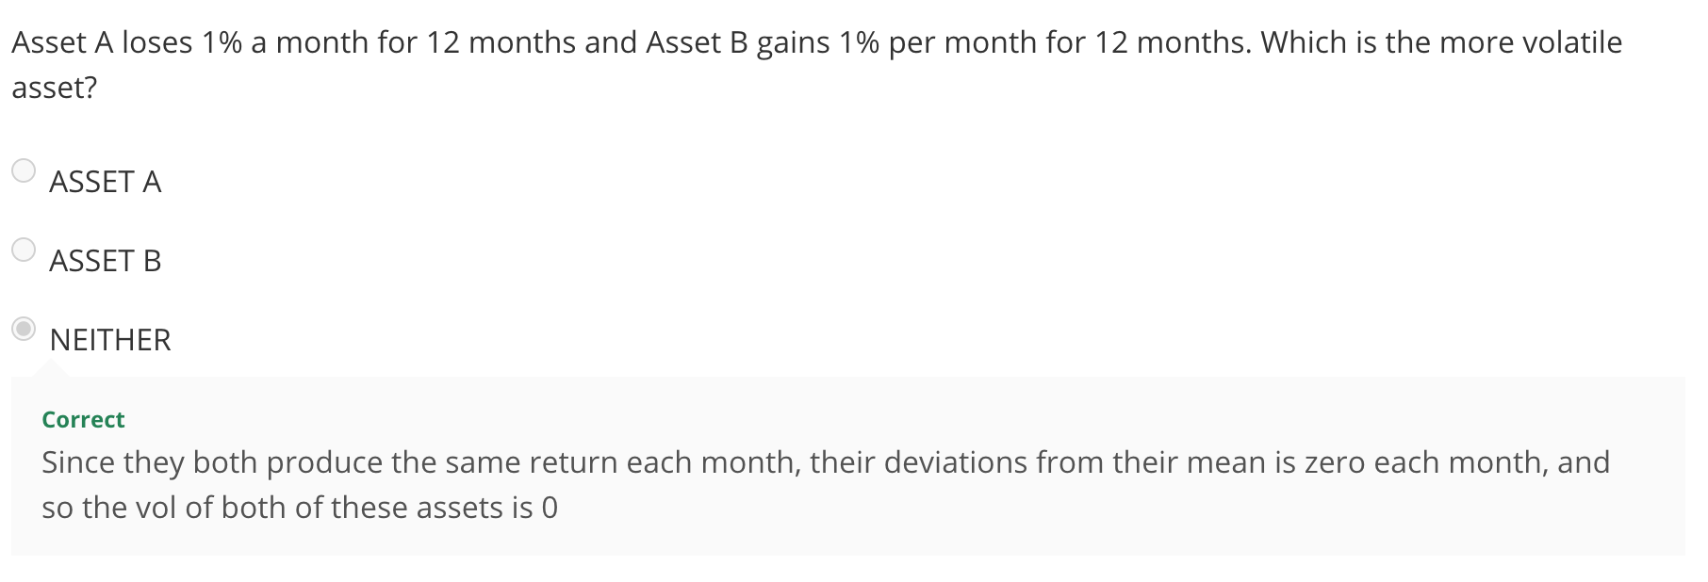

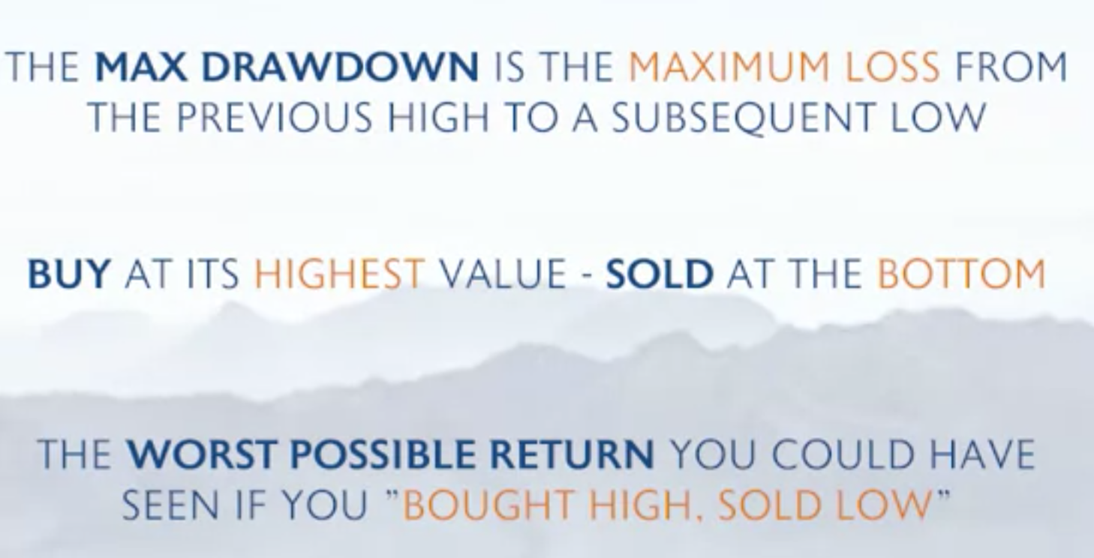

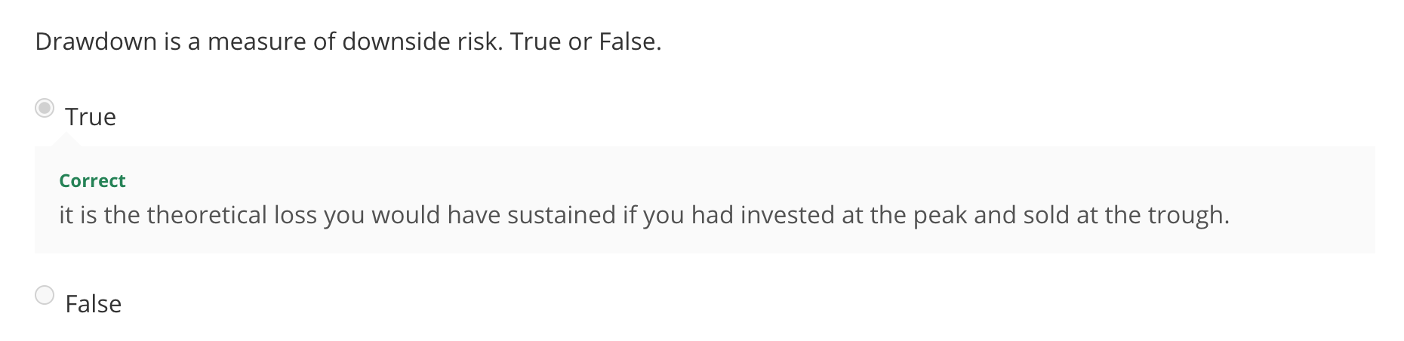

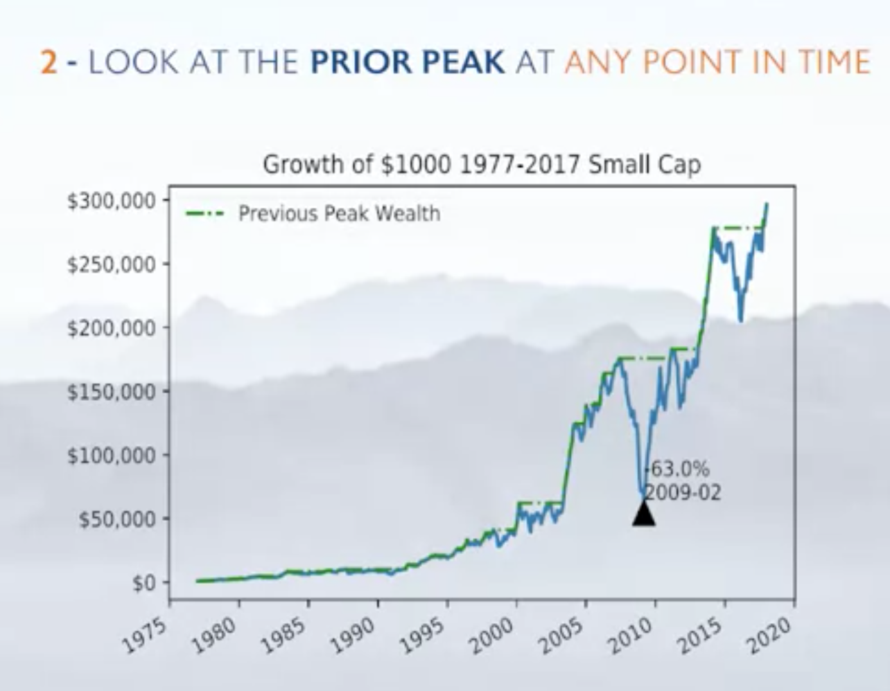

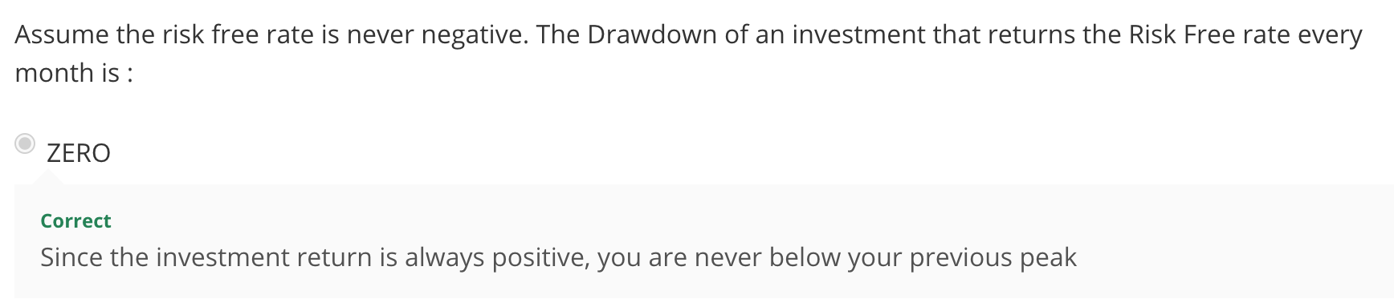

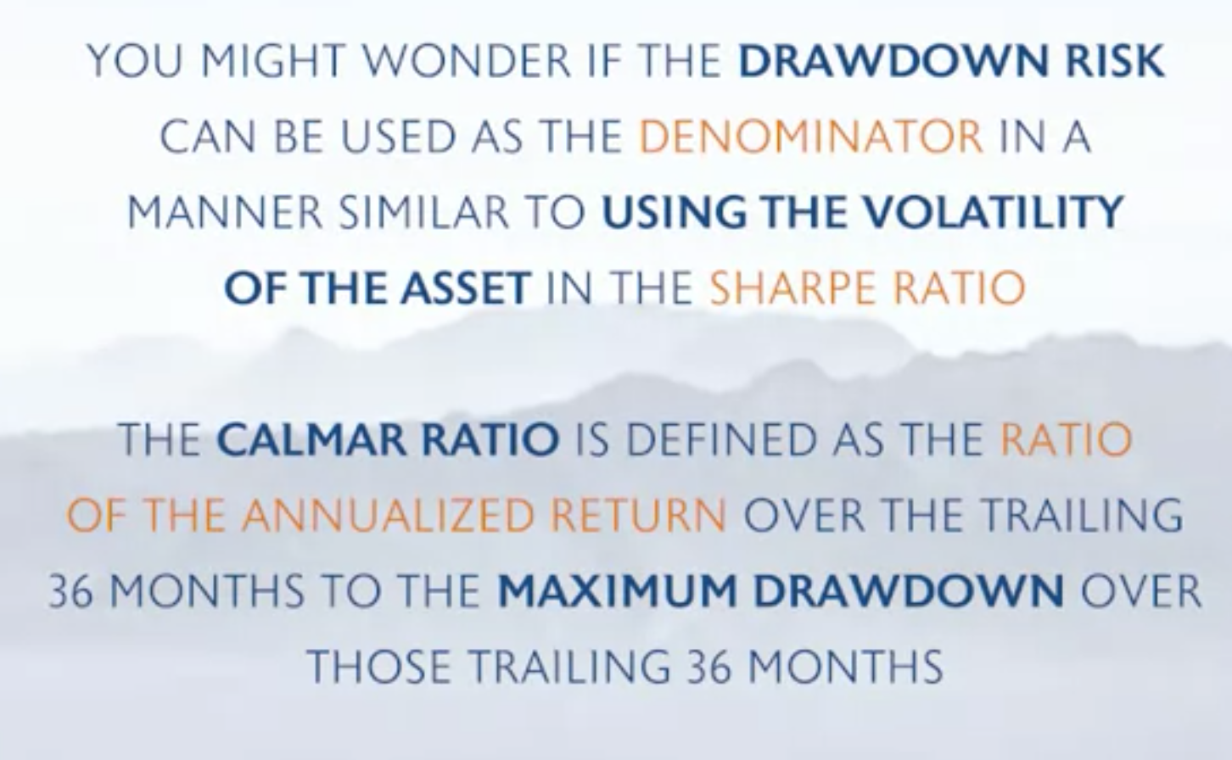

* Drawdowns on daily vs weekly basis will be very different. It’s incredibly sensitive to the granularity of the data
  + Var and cvar are probably a lot better

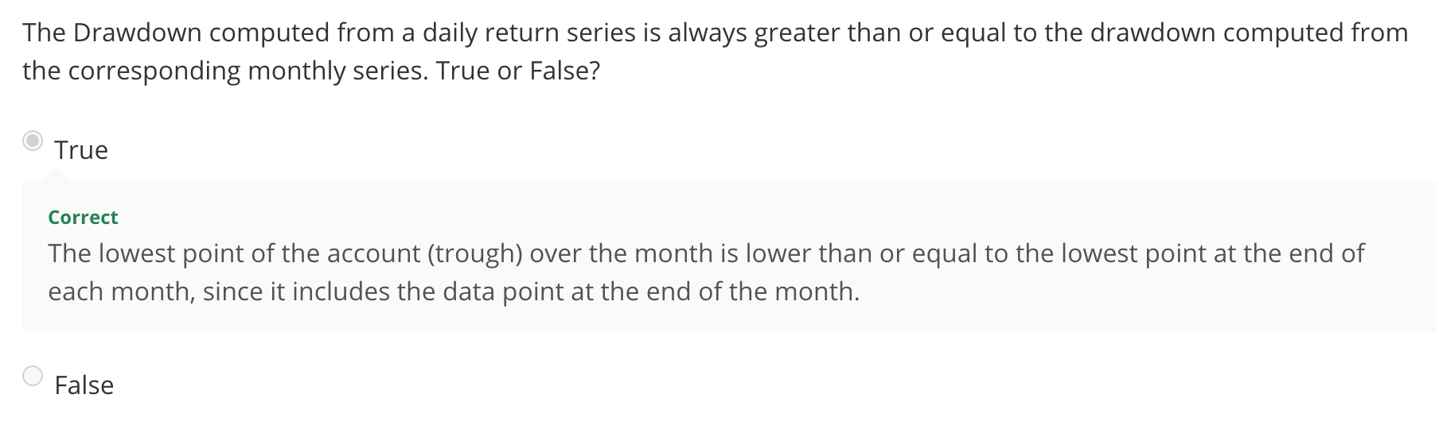

Lab session 3

Pd.to_datetime will presumably be very important

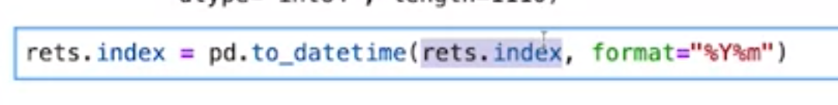

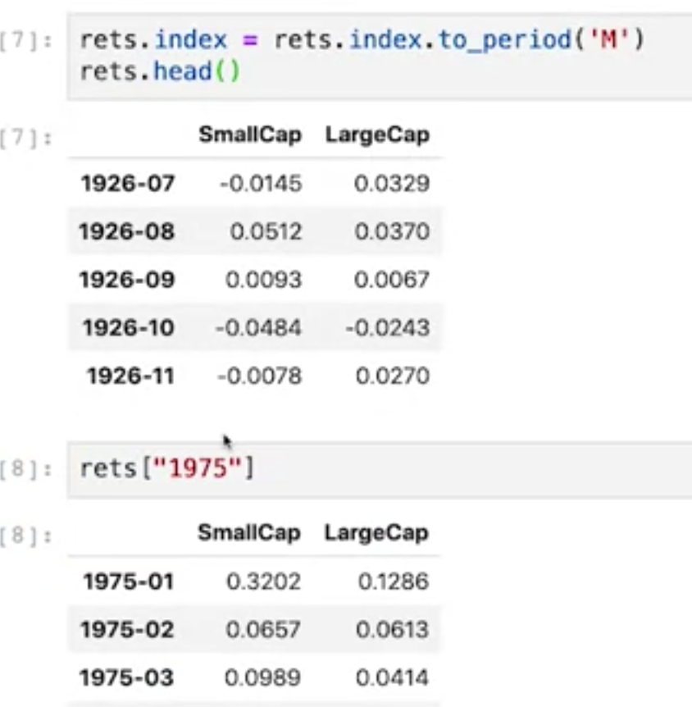

.to_period appears to be very important for interval management.

Creating a wealth index 🡪 Wealth is the **cumulative growth** of a 100x$ investment at time ti

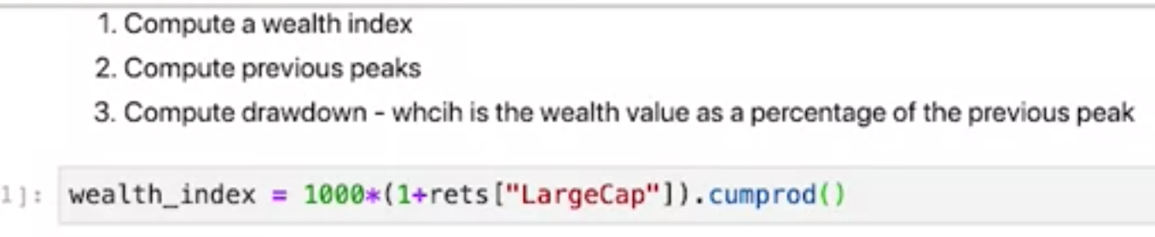

How to calculate and plot your drawdowns:

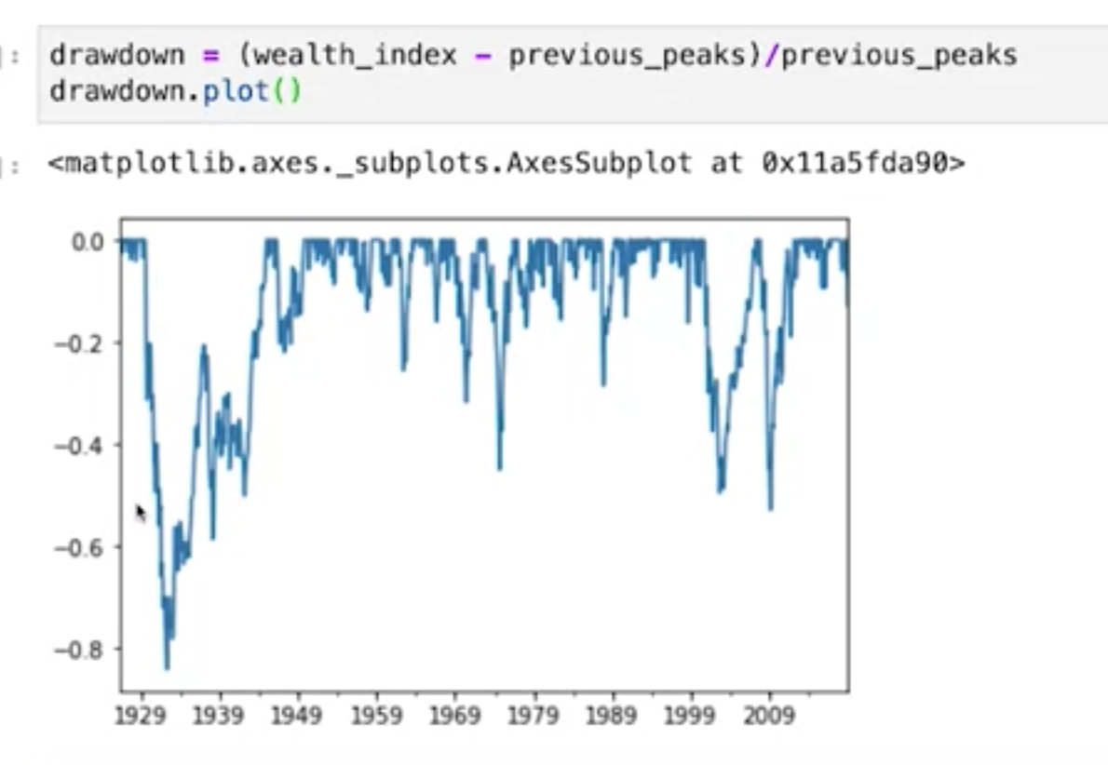

Fast way to index the min

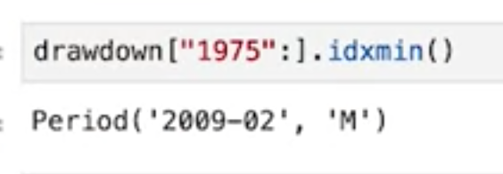

Video: Deviations from Normality

Normal distribution assumption is not great for simulating returns

* Negative skew 🡪 mean is less than the median. So probability for outcome above the mean is greater than probability for outcome below the mean.

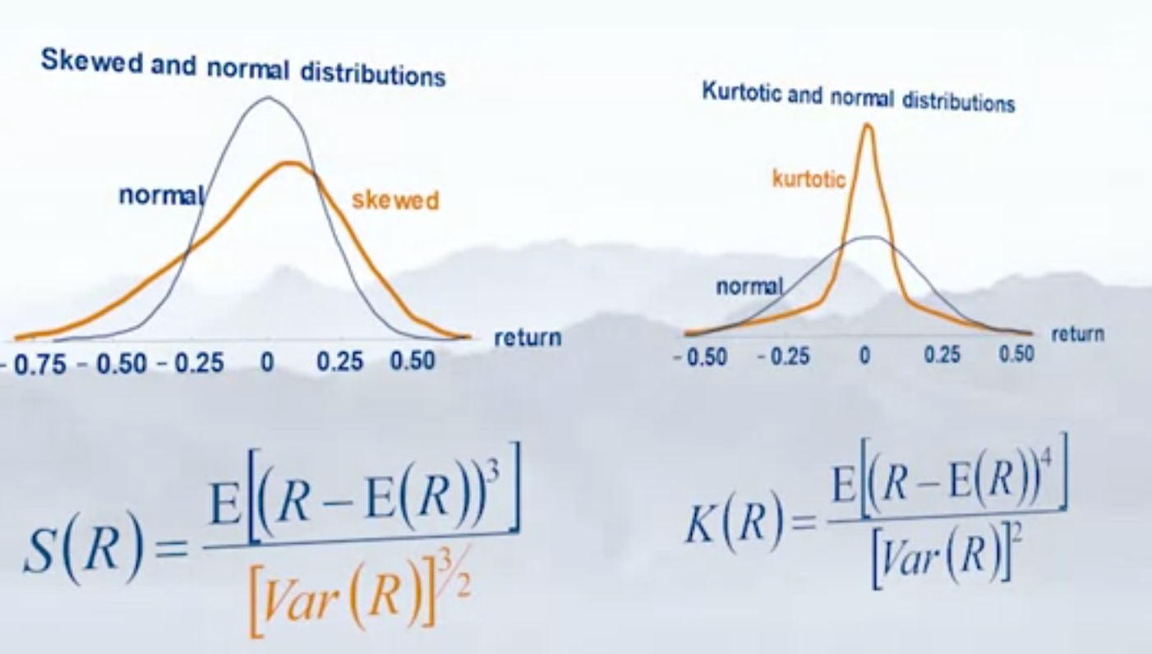

Kurtotis is essentially a measure of the width of the tails

* Kurtosis greater than 3 is considered “Fat Tail” distribution
* 3 is considered for normal distribution
* Things like scipy will give the excess kurtosis

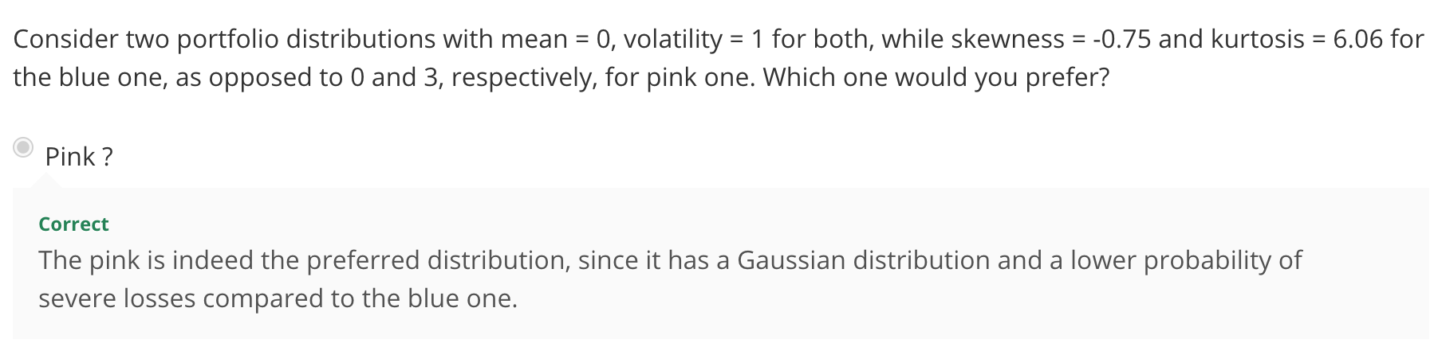

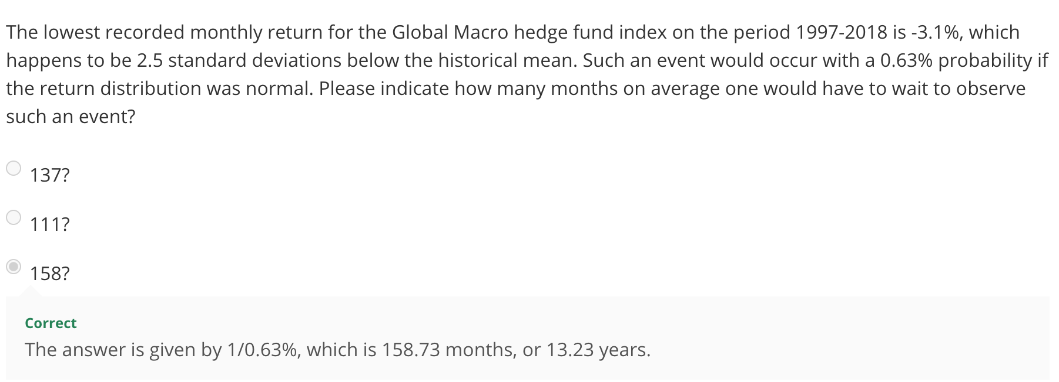

Jarque Bera can be used to evaluate whether or not a normal distribution would work

**Lab Session: Building your own modules**

Magic Command:

* Anything that starts with a percentage
* %Load_ext autoreload
  + UI will know it’s not python code
* %autoreload 2 will allow IDE to detect module changes, and will re-import them if necessary

%load-ext autoreload

%autoreload 2

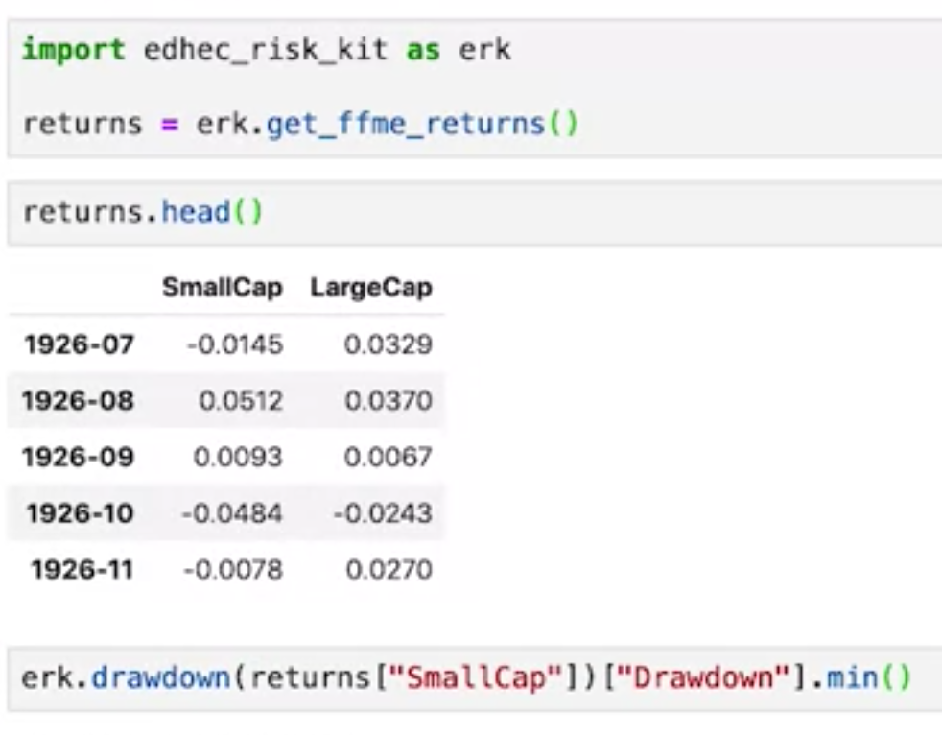

**Video: Downside Risk Measures**

* Remember that returns are not normally distributed
* Volatility is a very symmetric measurement, making it flawed

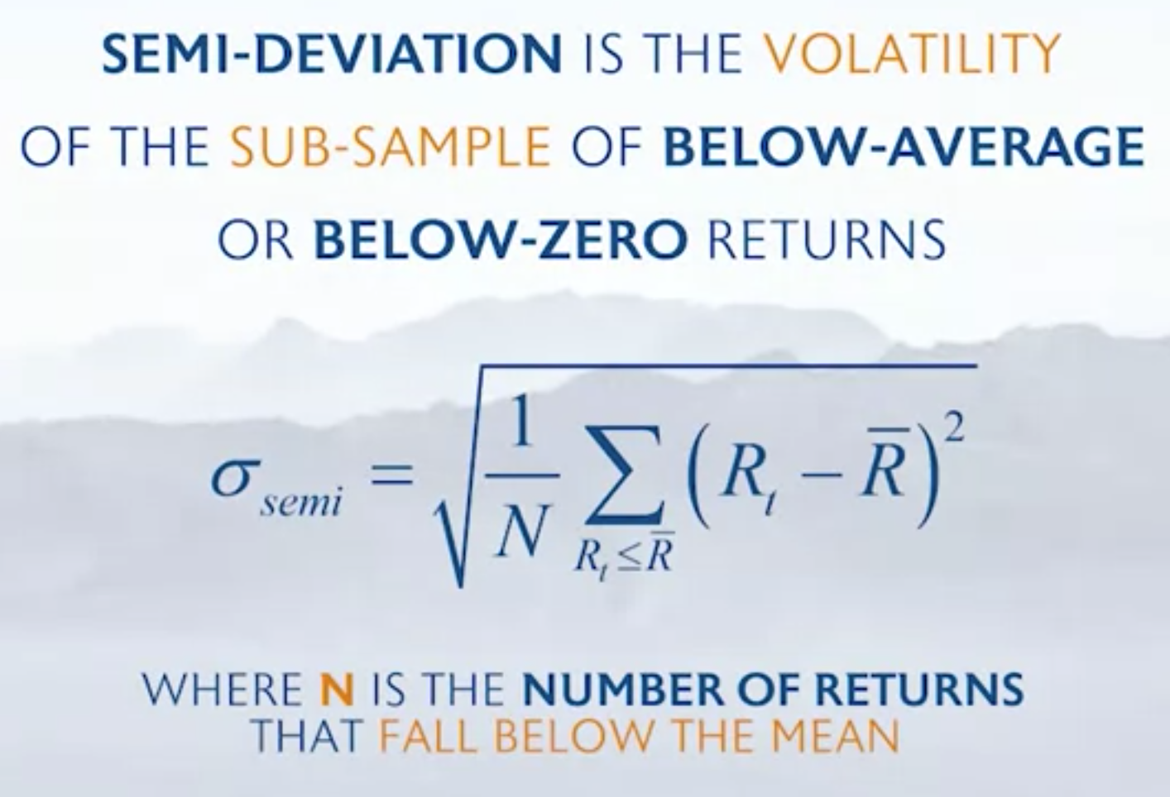

Value at risk (VAR):

* Represents the **maximum** expected loss over a given time period
* Occurs as a specified confidence level (ie 99%)
  + Worst possible outcome after excluding the 1% extreme losses
* Over a specified holding period
* Note that Var is often described as a positive value

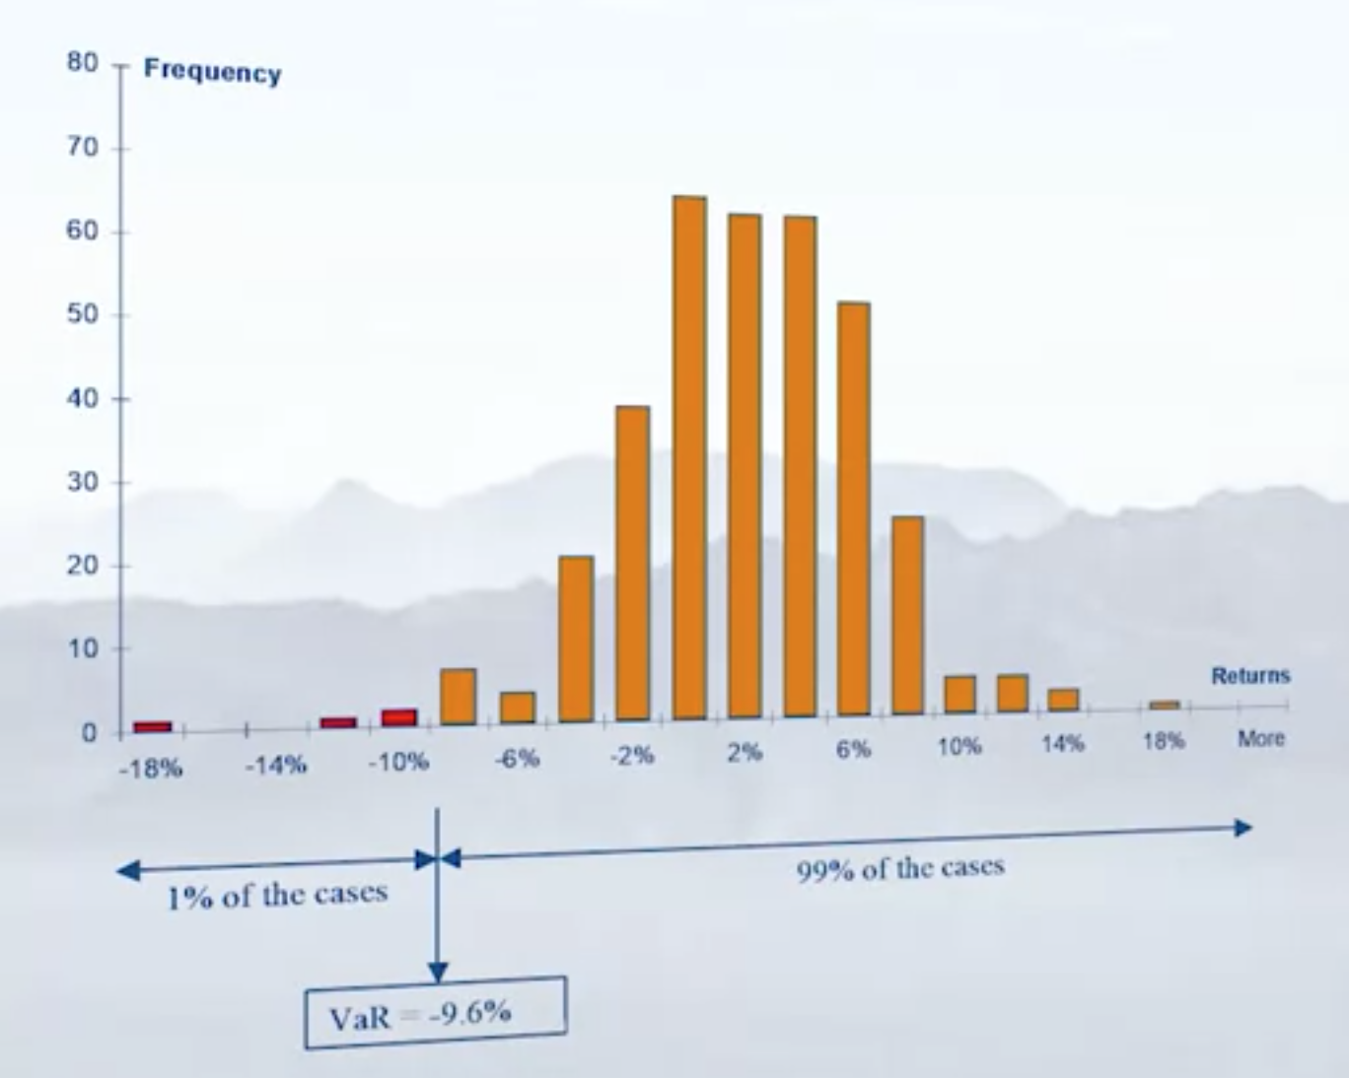

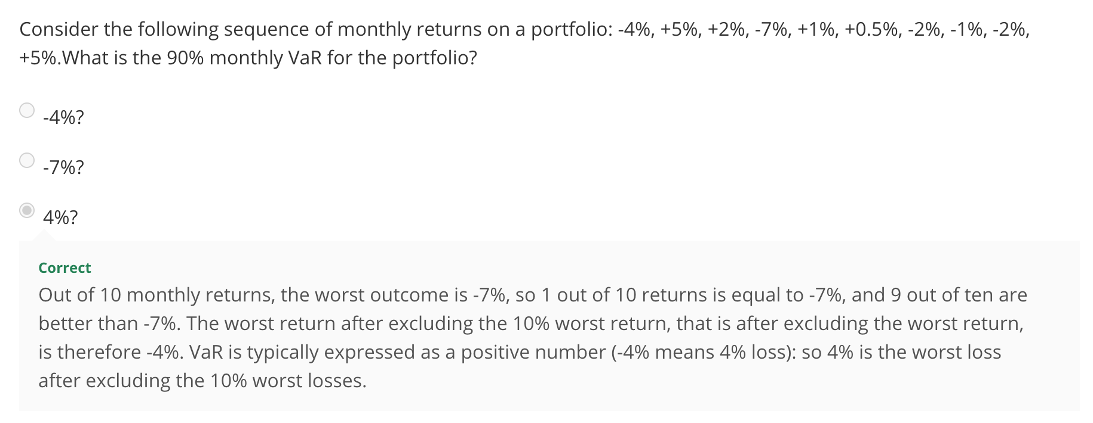

CVar (Conditional Value at Risk):

* Essentially the expected loss BEYOND Var

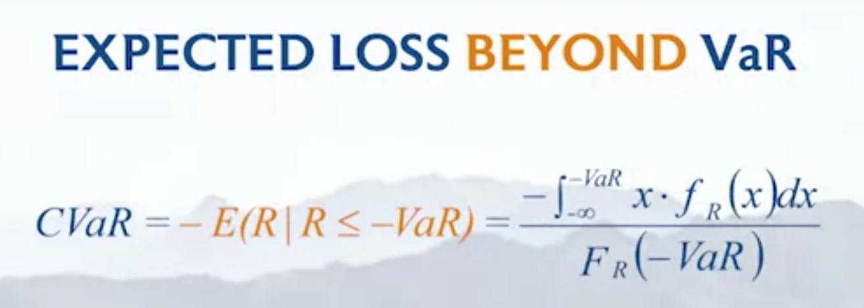

* Essentially average of values in our worst cases

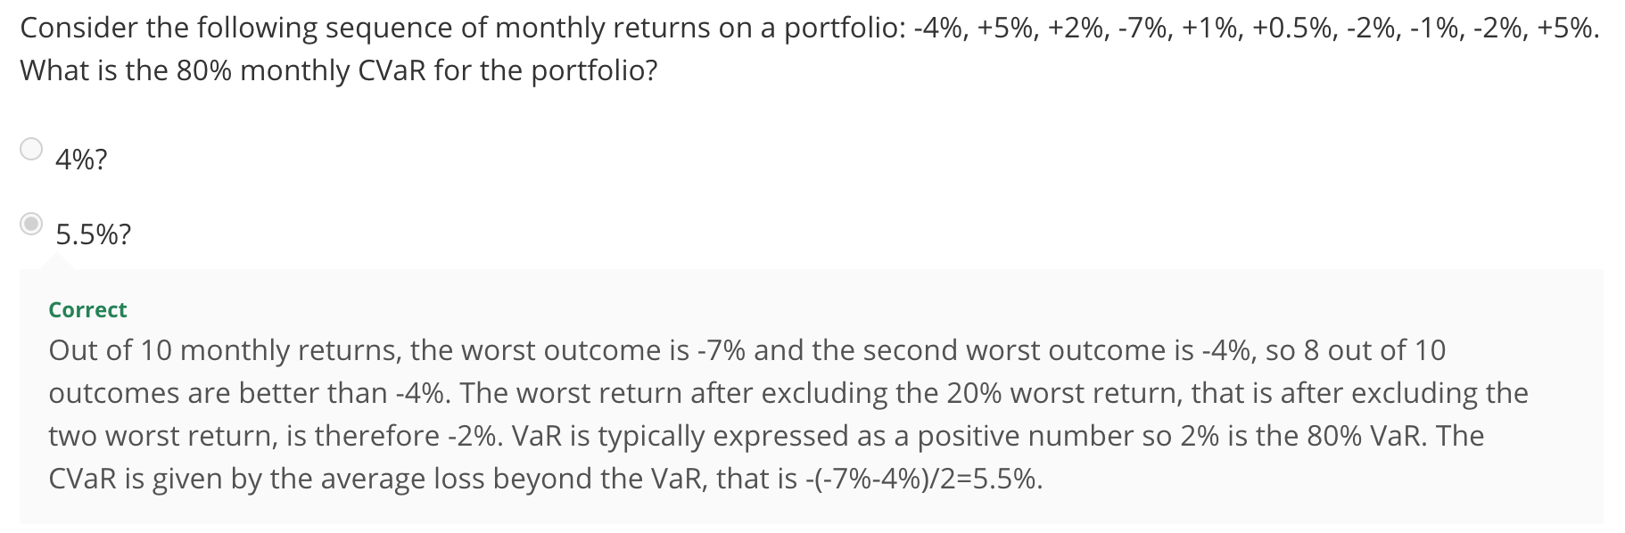

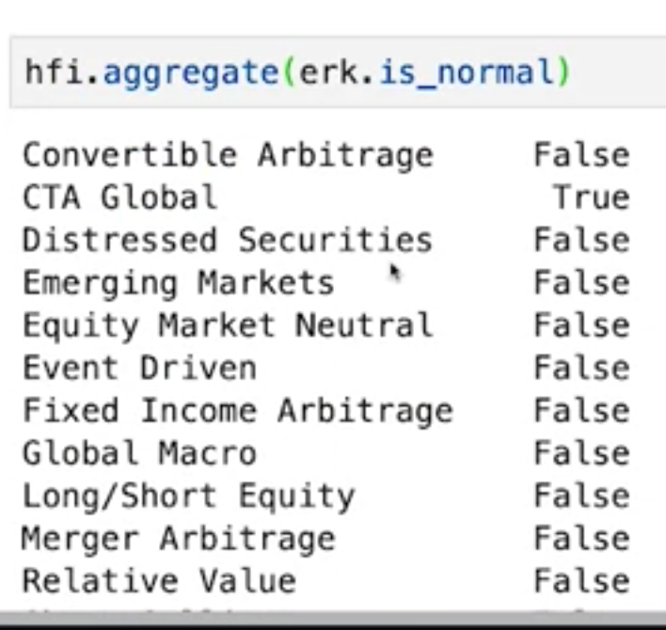

.aggregate is such a great function

* It essentially lets you the desired function to every single column in the dataframe

**Video: Estimating VaR**

Four standard methods for calculating Var:

1. Historical (non parametric)
   1. Solely relying on the historical data
   2. Exclude the 1 percent worst data
2. Variance-Covariance (parametric Gaussian)
   1. Starts with the assumption of gaussian distribution 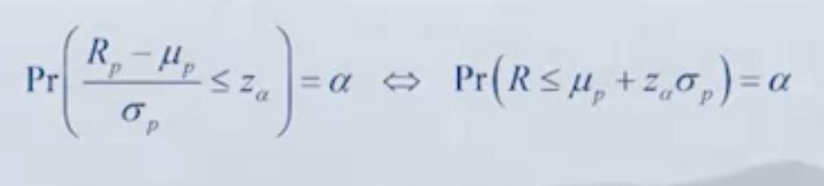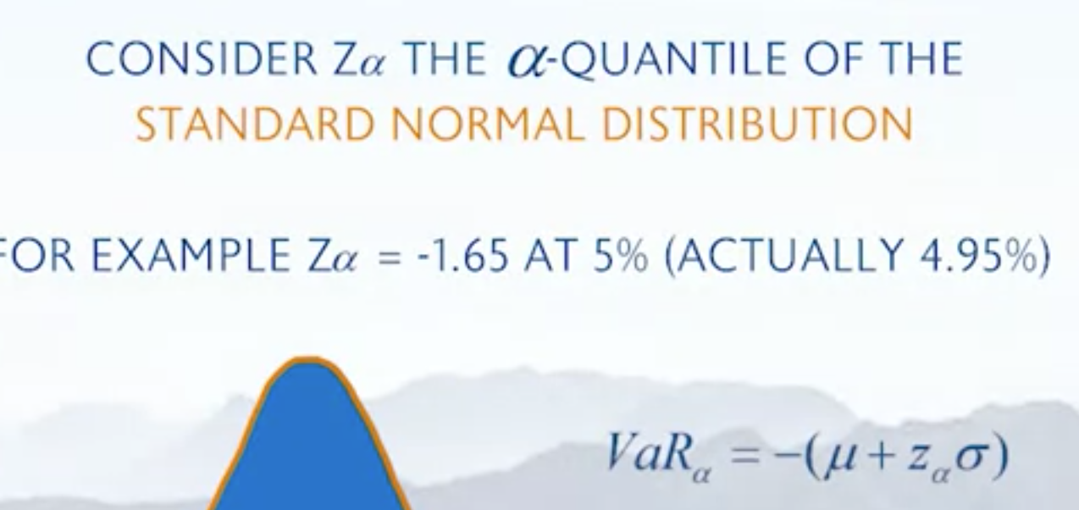
3. Parameteric Non Gaussian
   1. Because you’re assuming your parameters, you’re adding risk into your model
4. Cornish-Fisher (semi Parametric)

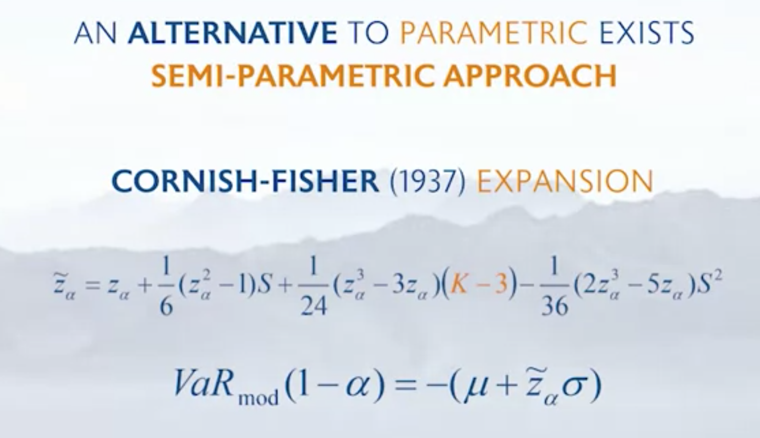

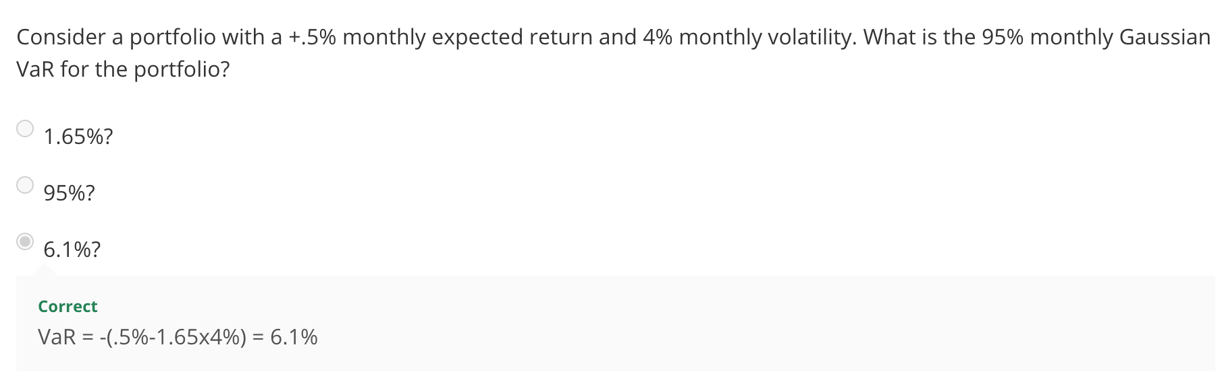

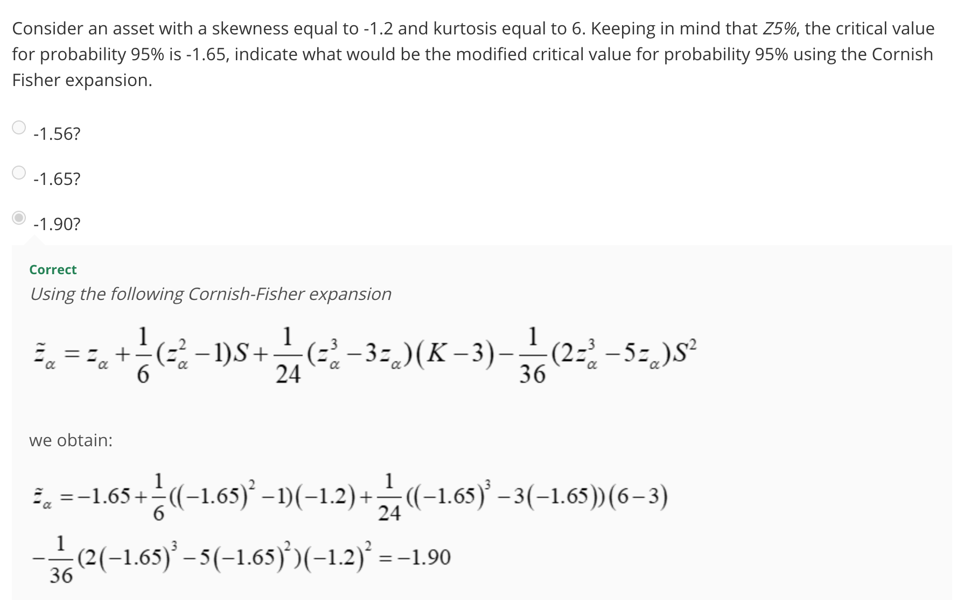

**Lab Session-Semi Deviation…:**